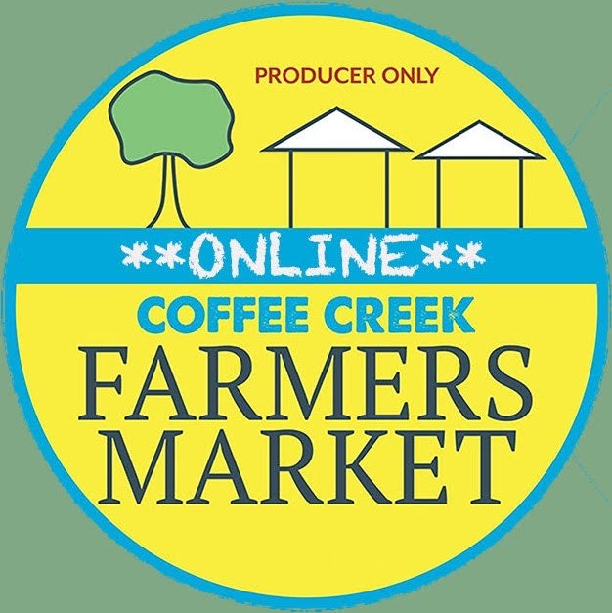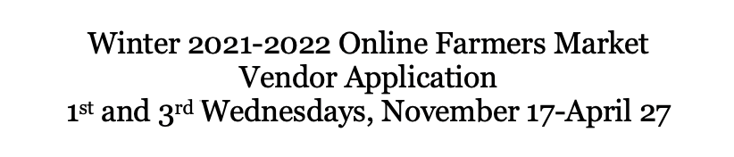
Name: __________________________ Business: ______________________________ Address: ________________________ City, State Zip: __________________________ Phone Number: ____________________ Email: _______________________________
TID # or Social Security #: ___________________
Business Type (circle one): Farmer Specialty Food Producer Artisan
Vendor Participation Cost: 15% of each order
Summarize what products you will be selling:
________________________________________________________________________ ________________________________________________________________________ ________________________________________________________________________ ________________________________________________________________________ ________________________________________________________________________ ________________________________________________________________________
I hereby certify that I have read the Coffee Creek Farmers Market Rules. As a participant in the Market I agree to abide by them. I agree to indemnify Native Roots Farm and their respective officers and directors from any liability due to damage and/or theft of merchandise, goods, and wares kept upon the premises designated by persons mentioned above, and any claim for personal injury relating to our participation in the Online Market. Vendors shall carry at least general liability insurance and name Native Roots Farm as additionally insured. Certificates must be provided.

____________________________________________________________________________________ (Signature) (Date)

